# CELL AND GENE THERAPY -

An Overview and Recent Developments



**SaSPinjara**

*Author:*

**Sachin Marihal** - (M.Pharm) R&D developing products for IND/NDA and Generics for US/EU/China/AUS.

**Newsletter Date**

### Introduction

Special points of interest:

* INTRODUCTION TO CGT
* CELL THERAPY AND TYPES
* GENE THERAPY AND TYPES
* RECENT DEVELOPMENTS

⇒ **USA**

⇒ **CHINA**

⇒ **INDIA**



Cell and Gene Therapy (CGT) is a rapidly evolving field that holds promise for the treatment of a wide range of diseases. CGT seeks to correct the root cause of an illness at the molecular level, often a rare inherited condition that can be life-threatening or debilitating and has limited treatment options1. These treatments aim to provide more precise and targetd therapies tailored to individual pati- enst. The game-changing medicines are reshaping how we

address previously untreatable illnesses – transforming people’s lives

### What is Cell and Gene Therapy (CGT)

***Fig-1 :*** *Illustration of steps involved in a cell therapy*

CGT represents overlapping fields of research with similar therapeutic goals – developing a treatment that can correct the underlying cause of a disease and aiming to address unmet med- ical needs, especially those that were previously considered incurable.

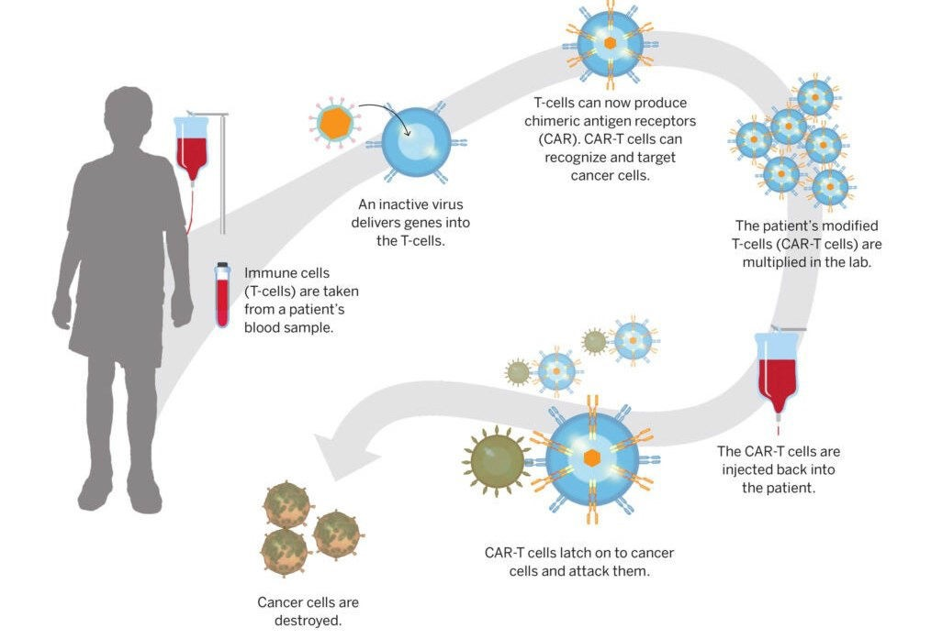

*Image source: The Harvard Gazette*

There are two types of CGT:

##### Cell Therapy

1. **Gene Therapy**

**Cell Therapy:**

This involves the use of living cells to replace or repair damaged tissue or cells. A brief illustration of the procedure is shown in fig-1.

**Stem cell**-based and **non-stem cell**-based cell therapies are the two broad categories of cell therapy1.

Stem cells can be sourced from various places, including bone marrow, umbilical cord blood, or induced pluripotent stem cells (iPSCs).

**(Stem Cell)**

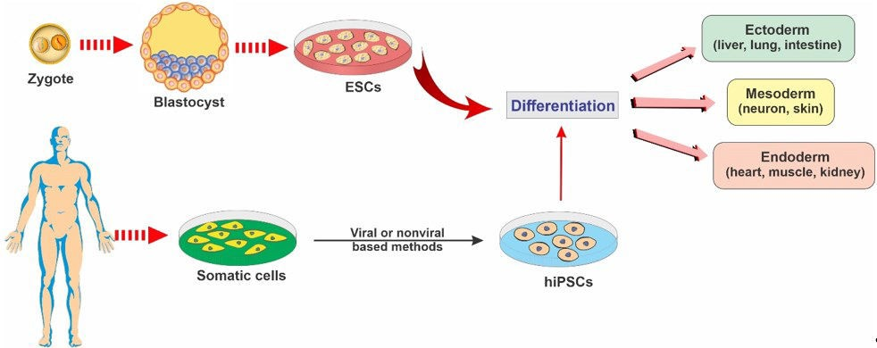

**(Non-Stem cell)**

***Fig-2*** *Difference between Stem Cell & non-Stell*

*Image source : mdpi.com/journal*

### Stem Cell Based

Stem cells are undifferentiated cells that can differenti- ate into specialized cells and divide to produce more stem cells. (as shown in fig-2). Stem cells can be ob- tained from various sources, including bone marrow, adipose tissue, and umbilical cord blood. Stem cell- based cell therapy has shown promise in the treatment of a wide range of diseases, including cancer, heart disease, and neurological disorders2.

Stem Cell Based

Non Stem Cell Based

Non-stem cell therapy uses cells that are already specialized and cannot differen- tiate into other cell types.

* Non-stem cell therapy targets specific disease processes or functions without necessarily aiming for tissue regenera- tion.

•Non-stem cell therapies might involve targeted therapies such as monoclonal antibody treatments for cancer, immuno- therapies, hormone therapies etc.

Stem cell therapy utilizes cells that have the potential to differentiate into various cell types .

* Stem cell therapy aims to repair, re- generate, or replace damaged tissues or cells .
* Stem cell therapy is applied in regen- erative medicine to treat conditions such as orthopedic injuries, heart diseases, neurological disorders, and autoimmune diseases.

Page 2

### Non-Stem Cell Based

Non-stem cells can be obtained from various sources, including blood, skin, and muscle tissue (as shown in fig-

2) Non-stem cell-based cell therapy has shown promise in the treatment of a wide range of diseases, including diabetes, heart disease, and neurological disorders2.

### Gene Therapy

Gene Therapy involves the introduction of specific DNA sequences into a patient’s body to treat, prevent, or po- tentially cure a disease Gene therapy may involve the delivery of a functional gene into cells to replace a gene that is missing or causing a problem – or other strategies using nucleic acid sequences (such as antisense oligonucle- otides or short interfering RNAs [siRNAs]) to reduce, re- store, or modify gene expression1. The fig-3 showa graph- ical representation of a therapeutic DNA sequence being en- capsulated in an AAV (Adeno-Associated Virus). This is a tech- nique used in gene therapy to deliver genes of interest into target cells.

### Gene Therapy Classification:

##### 1. Somatic Cell Gene Therapy:

This involves the transfer of genetic material into the cells of an individual to treat a specific disease. The genetic material is transferred into the somatic cells, which are the non-reproductive cells of the body. This type of gene ther- apy is not passed on to future generations3.

###### 2. Germline Cell Gene Therapy:

Germline Gene Therapy: This involves the transfer of ge- netic material into the reproductive cells of an individual to treat a specific disease. The genetic material is trans- ferred into the germ cells, which are the cells that give rise to the eggs and sperm. This type of gene therapy is passed on to future generations3.

Fig-4 gives a comparative illustration between the above 2 types of gene therapies.

##### 3. In Vivo Gene Therapy:

This involves the direct transfer of genetic material into the cells of an individual within the body. This type of gene therapy is used to treat diseases that affect a specific organ or tissue3. **Fig-5** illustrating the process of Ex-vivo and

**Fig-5**:

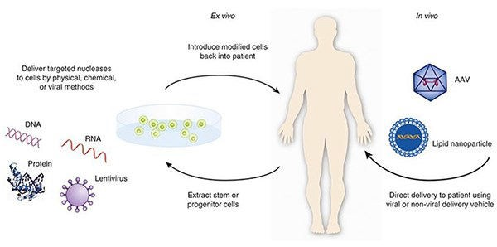

Diagram illustrating the two methods of delivering targeted nucleases: ex-vivo and in vivo. In-vivo

**Fig-3** : Graphical representation of a therapeutic DNA sequence being encapsulated in an AAV (Adeno-Associated Virus)

*Image source :* [*www.sanofi.com*](http://www.sanofi.com/)

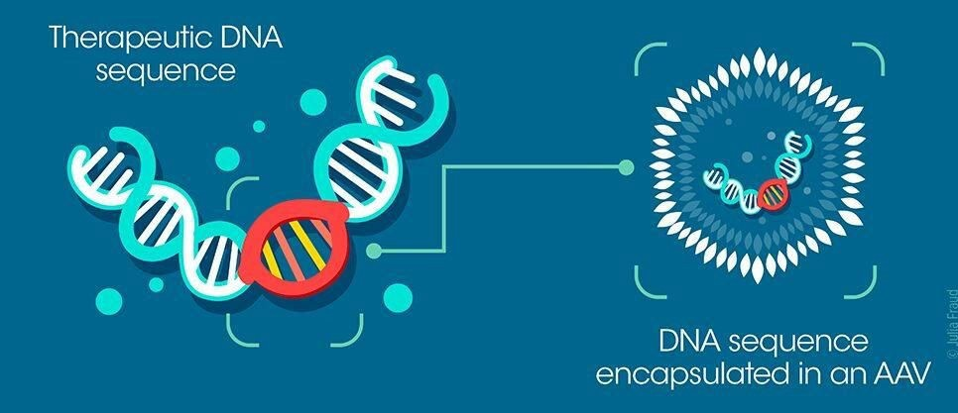

**Fig-4** : Comparative diagram illustrating the differences between Germline Gene Therapy and Somatic Gene Therapy.

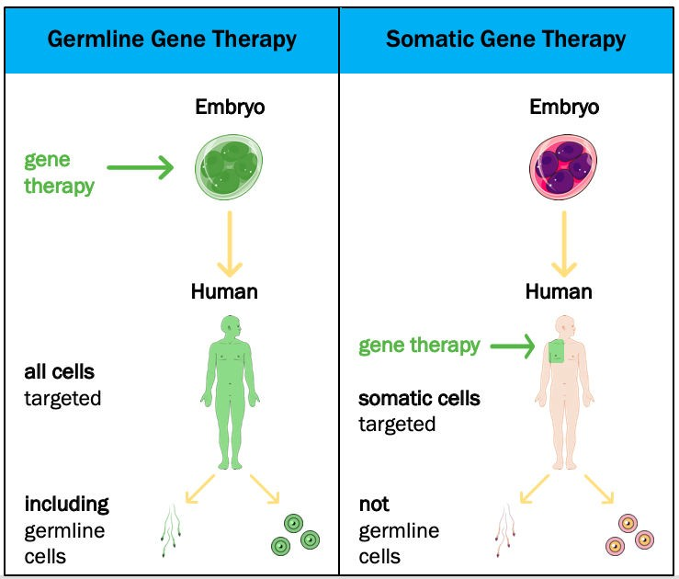

*Image source : immigrant.com.tw*

##### Ex Vivo Gene Therapy:

This involves the transfer of genetic material into cells that have been removed from an individual’s body1. The cells are then modified outside the body before being returned to the individual. This type of gene therapy is used to treat diseases that affect

*Image source:* [*www.jspeboston.org*](http://www.jspeboston.org/)

Page 3

### Recent Advances in CGT

##### United States: Pioneering the Future of Medicine.

In the United States, CGT is seen as the future of medicine. Experts have evaluated the future of CGT in the US, offering insights on potential value- based payment models for these treatments4. The goal for CGT is to pro- vide a potential one-time treatment that could last anywhere from 5 to 20 years, offering significant clinical durability and efficacy for patients with chronic conditions4.

One of the therapies on the market today is Zolgensma (onasemnogene abeparvovec-xioi) for spinal muscular atrophy (SMA). This treatment gives patients lacking the SMN1 gene a working copy of SMN1 that they will have in their body for the rest of their lives4. Multiple companies are also working to bring hemophilia gene therapies to market4.

Fig-6 gives a illustration of Gene Therapy for SMA

##### China: Booming Landscape under Dual-Track Regulation

ZOLGENSMA

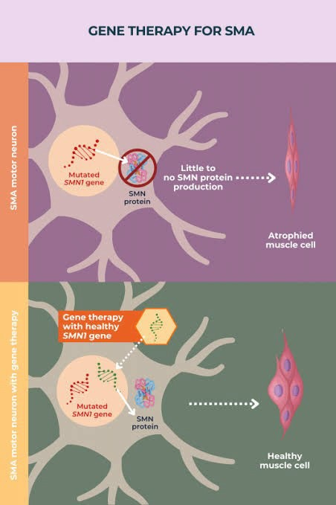

(SMA GENE THERAPY)

**Fig-6** : A illustrative diagram explaining “GENE THERAPY FOR SMA”

**CGT Clinical trial Comparission for top 10 major regions.**

China has seen a boom in CGT, especially in the field of

cancers1. The country has adopted a dual-track regulatory system for CGT, which allows for both accelerated and conditional approvals. This has led to a surge in the number of clinical trials for CGT in China. Graph-1 gives

comparative data for number of drugs

800 **PHASE 3** As of 26/01/2024

700

600

500

**Graph-1**

400

300

200

100

0

754

402

81



93 12



703

6 34

Over the past 9 years, the use of CAR T-cell therapies has expanded throughout

*Data Insights Powered by* **Pharmacodia Global**– *A first tier global database*

According to an analysis sourced from **Pharmacodia Global** - *A first tier database*, as shown in the Graph-2. the development of CAR-T therapies in China appears to markedly outpace research happening in the West. China accounts for more 50% of all new drugs development hap- pening in the field of CAR-T globally, compared to 25% of CAR-T thera- pies development by US companies.

China, from the first clinical trials of CAR T cells conducted in 2013, to the world’s largest number of CAR T-cell- related clinical trials, to a cumulative US$2.37

***billion in funding.***

Graphical comparision of Total Drugs under Development V/S Cell Therapy and CAR-T in US and China.

**Graph-3**

389

China

703

4787

196

US

754

5916

0

1000

2000

3000

4000

5000

6000

7000

CAR-T Cell Therapy All Medicines

*Data Insights– Powered by* ***Pharmacodia Global****—A first tier pharmaceutical database.*

**India: Emerging as a Key Player**

India’s IST CAR-T Therapy

* **Indigenously-developed CAR-T cell therapy product NexCAR19 .**
* **Collaborative effort across a decade between IIT Bombay and Tata Memorial Centre (TMC).**
* **Significant cost advantage compared to similar therapies in the US and China.**

India’s first CAR-T cell therapy, NexCAR19 is expected to provide a significant cost advantage compared to similar therapies in the US and China8. The therapy, which is likely to be priced at one tenth the price of that in US for single dose

range, will give patients in India and other countries with lim- ited resources access to this lifesaving cutting edge therapy at an affordable cost..

NexCAR19 is the result of a collaborative effort across a decade between IIT Bombay and Tata Memorial Centre (TMC). Designed and developed at IIT Bombay, NexCAR19

subsequently underwent integrative process development and manufacturing under cGMP at ImmunoACT. Clinical investigations and translational studies were conducted by teams at TMH.

**Conclusion:**

The dynamic landscape of cell and gene therapy unveils a promising era in the realm of medical advancements. This overview has explored the foundational principles of these innovative therapies, emphasizing their potential to revo- lutionize healthcare.

The recent advances in research and development (R&D) emanating from powerhouse nations like the United States and China underscore a pivotal era of global innovation. These countries, at the forefront of scientific and technolog- ical breakthroughs, continue to reshape the landscape of progress across diverse domains.

As we stand on the precipice of a new era in personalized medicine, the synergy between scientific ingenuity and clinical applications in cell and gene therapy is evident. The collaborative efforts of researchers, clinicians, and in- dustry pioneers herald a future where debilitating diseases may be effectively addressed at their genetic core. As we navigate this frontier of medical innovation, the commitment to scientific rigor, ethical conduct, and patient- centric approaches will be paramount. With each milestone achieved, the vision of a healthcare landscape trans-

formed by cell and gene therapy becomes increasingly tangible, offering hope for improved outcomes and quality of life for patients around the world.

Approved CAR-T Therapies Globally

*Data Source -* ***Pharmacodia Global****—A first tier pharmaceutical database.*

|  |  |  |  |  |  |
| --- | --- | --- | --- | --- | --- |
| **Drug Name** | **Global Highest Status** | **Highest Status in China** | **Original Approved Year** | **Approved Country/ Territory** | **Original Approved Country/ Territory** |
| Inaticabtagene Autoleucel | Approved | Approved | 2023 | Mainland China; | Mainland China; |
| Equecabtagene Autoleucel | Approved | Approved | 2023 | Mainland China; | Mainland China; |
| Ciltacabtagene autoleucel | Approved | NDA/BLA | 2022 | States;  Mainland China; Japan; EU; | United States; |
| Relmacabtagen e autoleucel | Approved | Approved | 2021 | Mainland China; | Mainland China; |
| Idecabtagene vicleucel | Approved |  | 2021 | Netherlands, UK, US, EU,  Japan | United States; |
| Lisocabtagene maraleucel | Approved |  | 2021 | Netherlands, UK, US, EU,  Japan | United States; |
| Brexucabtagen e autoleucel | Approved |  | 2020 | Netherlands, UK, US, EU,  Japan | United States; |
| Axicabtagene ciloleucel | Approved | Approved | 2017 | United States; Mainland China; JapaEnU; ; | United States; |
| Tisagenlecleucel | Approved | Phase 3 Clinical | 2017 | United States; EU; | United States; |
| Sipuleucel-T | Approved | Phase 3 Clinical | 2010 | United States; | United States; |

As of 26/01/2024

#### References

* 1. *https:*[*//www.*](http://www.technologynetworks.com/biopharma/articles)*te*[*chnologynetworks.com/biopharma/articles*](http://www.technologynetworks.com/biopharma/articles) *by Alison Halliday, PhD .*
  2. [*www.frontiersin.org.*](http://www.frontiersin.org/)
  3. *American Society of Gene and Cell Therapy. Gene & Cell Therapy FAQs. (2021). Available online at: https:// asgct.org/education/more-resources/gene-and-cell-therapy-faqs*

1. *Genetic Therapies - Types | NHLBI, NIH An official website of the United States government .*
2. [*www.thelancet.com/pdfs/journal*](http://www.thelancet.com/pdfs/journal)
3. *Funding & tenders (europa.eu) Emerging Technologies in Cell and Gene therapy.*
4. *https://doi.org/10.1016/S2352-3026(22)00291-5 Institute of Hematology, Zhejiang University, Hangzhou, China Liangzhu Laboratory, Zhejiang University Medical Center, Hangzhou, China*

*Zhejiang Province Engineering Laboratory for Stem Cell and Immunity Therapy, Hangzhou, China*

1. *https:*[*//www.*](http://www.pharmaceutical-technology.com/features/tracking-the-rise-of-car-ts-in-china-the-dawn-of-an-)*ph*[*armaceutical-technology.com/features/tracking-the-rise-of-car-ts-in-china-the-dawn-of-an-*](http://www.pharmaceutical-technology.com/features/tracking-the-rise-of-car-ts-in-china-the-dawn-of-an-) *immunotherapy-superpower/*
2. *https://timesofindia.indiatimes.com/home/science/*